e-Project

Courier Management
System

Batch Code
AI-202505A

Group Members

Serial Number | Enrollment Number | Student Name
16 | Student1643721 | Warda Malik
2 | Student1655615 | Amna Sajid
3 | Student1643790 | Nimra Ghori
4 | Student1667234 | Muhammad Saad

Acknowledgment

First and foremost, we would like to express our sincere gratitude to our teacher, Mr. Sir Abdullah Humayun Aziz, for his valuable guidance, encouragement, and continuous support throughout the completion of this project. His insightful suggestions and motivation played a vital role in helping us successfully finalize our work within the given time frame.
We would also like to extend our heartfelt thanks to the e-Project Team at Aptech Head Office for providing us with this wonderful opportunity to work on such an exciting and creative project about a Courier Management System. This project has been a truly enriching experience, offering us several key benefits, including:
- Reinforcement of our skills through practical and experiential learning.
- Consistent guidance from mentors to help us stay focused and organized.
- Increased confidence to face interviews and discuss our learning in depth, supported by real project experience.

Problem Statement
Problem statement is attached separately in a file “Courier Management System”
Standards plan:
Every code block must have comments.
The logic of the program needs to be explained. Proper documentation should be maintained.
Complete Project Report along with synopsis, code and documentation should be prepared.

Documentation:
No project is complete without documentation. In fact, it is one of the most important activities during the development of a project. The documentation of an ideal project will be in the form of a project report comprising of the following documents:

- Certificate of Completion.
- Table of Contents.
- Problem Definition.
- Customer Requirement Specification.
- Project Plan.
- E-R Diagrams.
- Algorithms.
- GUI Standards Document.
- Interface Design Document.
- Task Sheet.
- Project Review and Monitoring Report.
- Unit Testing Check List.
- Final Check List.

Hardware/ Software Requirements

Hardware:
- A minimum computer system that will help you access all the tools in the courses is a Pentium 166 or better
- 128 Megabytes of RAM or better

Operating System:
- LINUX / Windows 2000 Server (or higher if possible)

Software:
- PHP
- MySQL
- PERL
- Apache

Objectives of the project
The Objective of this program is to give a sample project to work on real life projects. These applications help you build a larger more robust application.

The objective is not to teach you concepts but to provide you with a real life scenario and help you create applications using the tools.

You can revise them before you start with the project.
It is very essential that a student has a clear understanding of the subject.
Kindly get back to e-Projects Team in case of any doubts regarding the application or its objectives.
Screen Shots
User:

Login Screenshot:
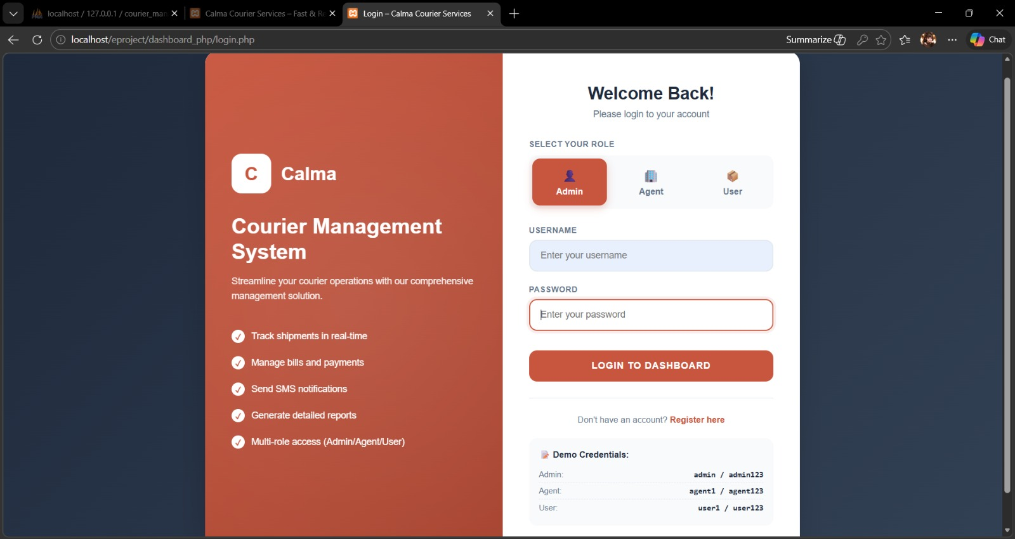

Register Screenshot:
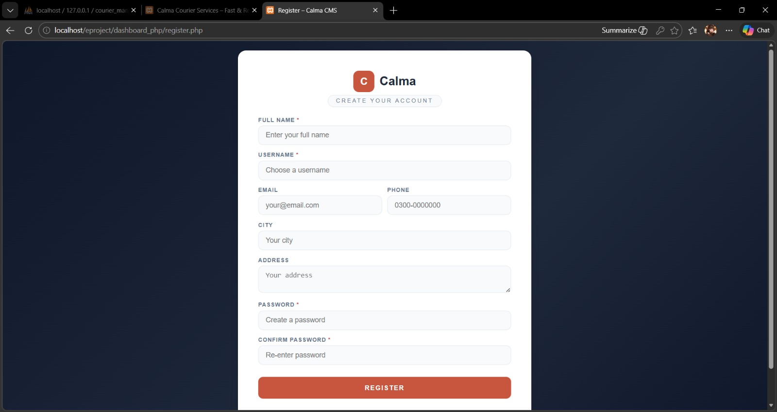

Navbar Screenshot:

Footer Screenshot:

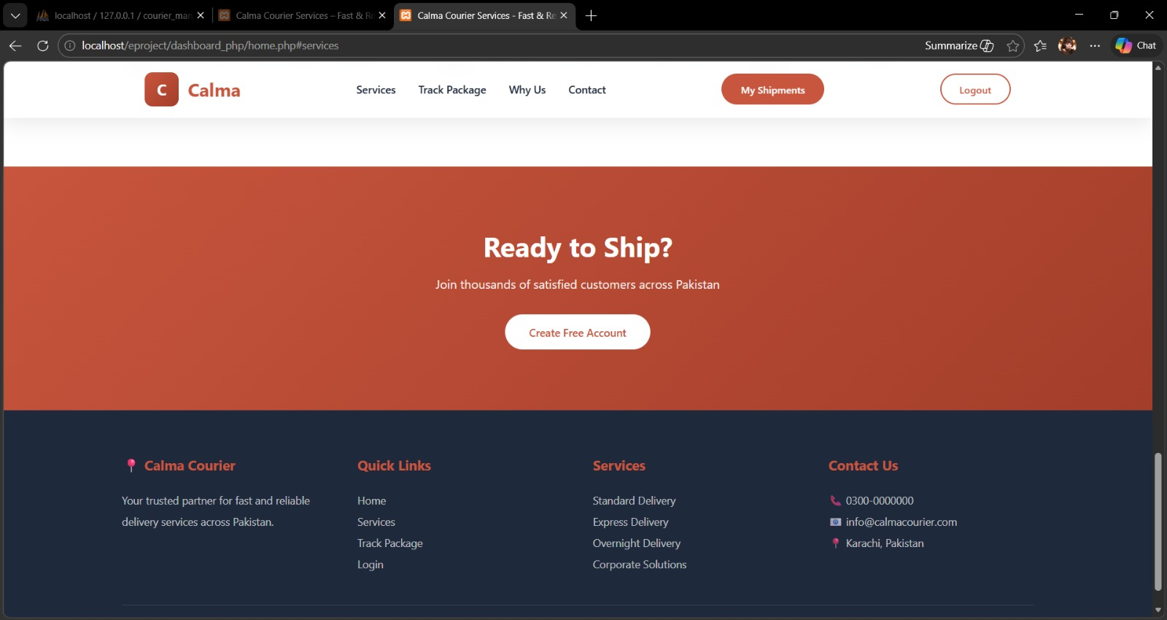

Home Page:

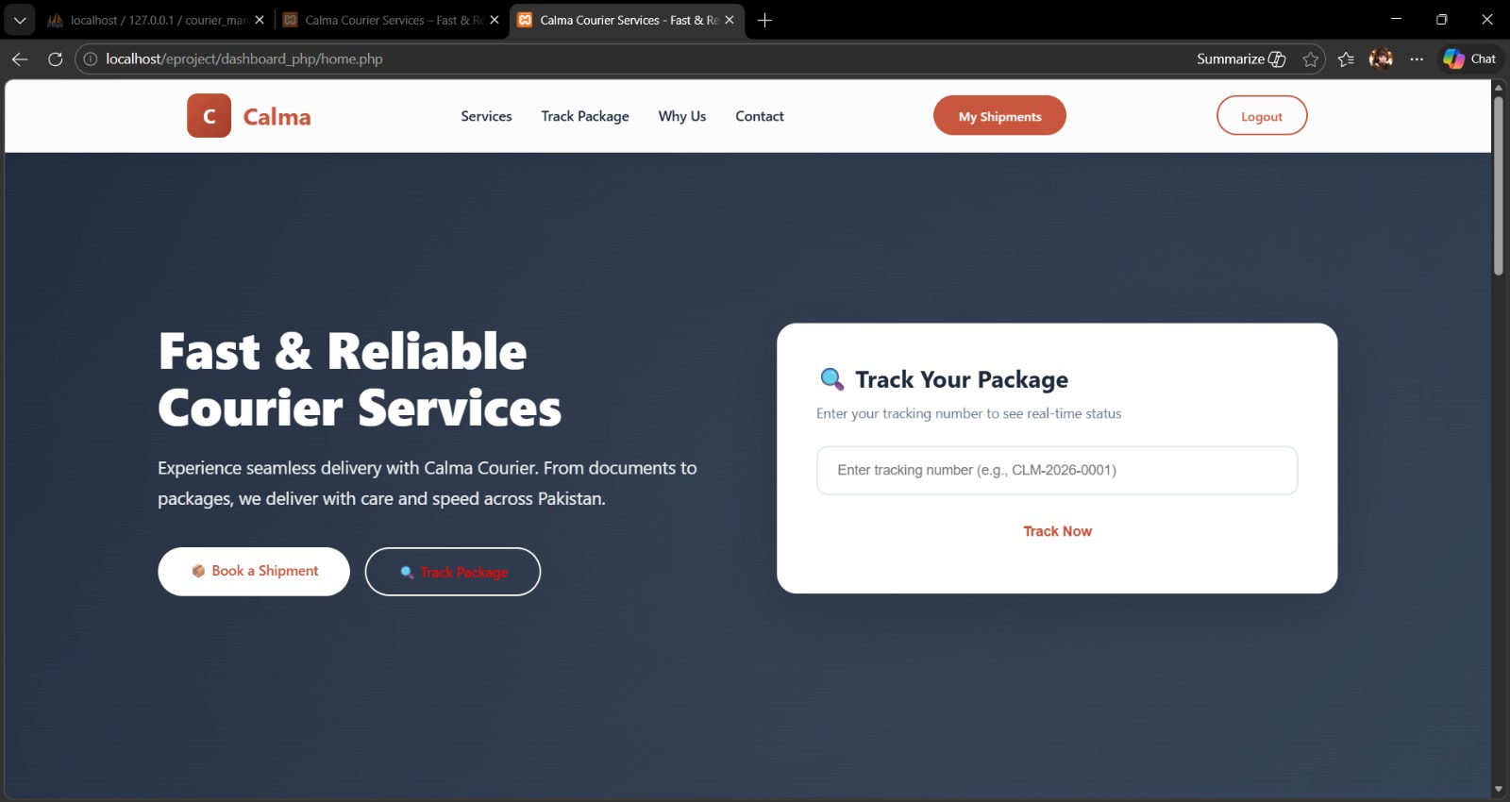

Services:

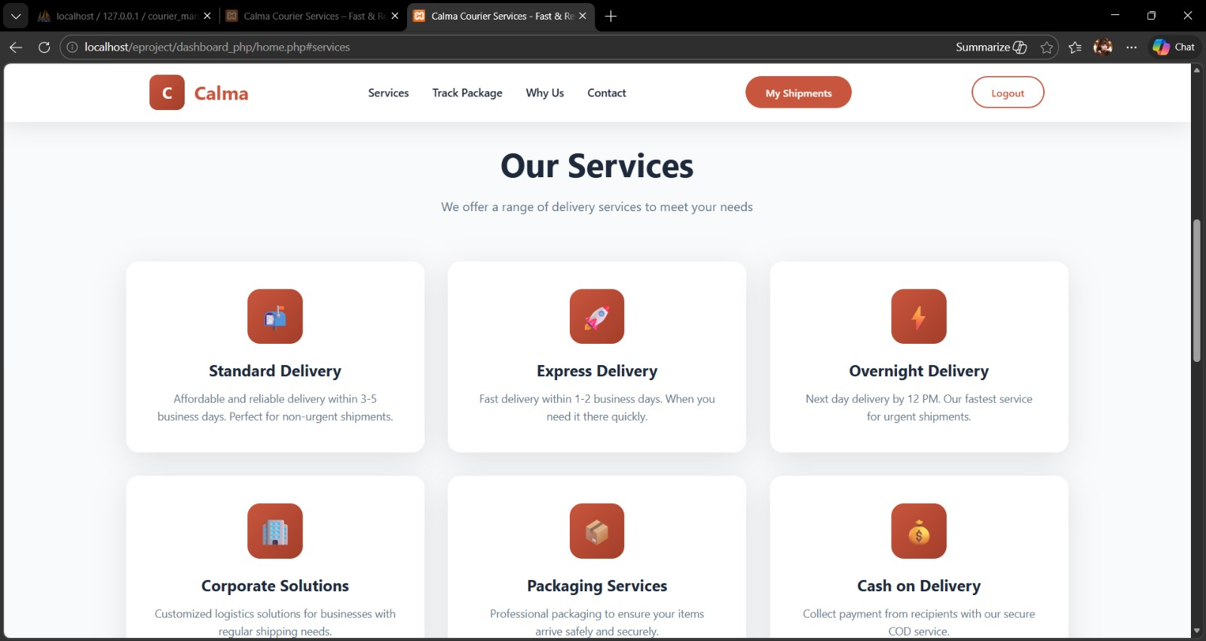
Track Package:
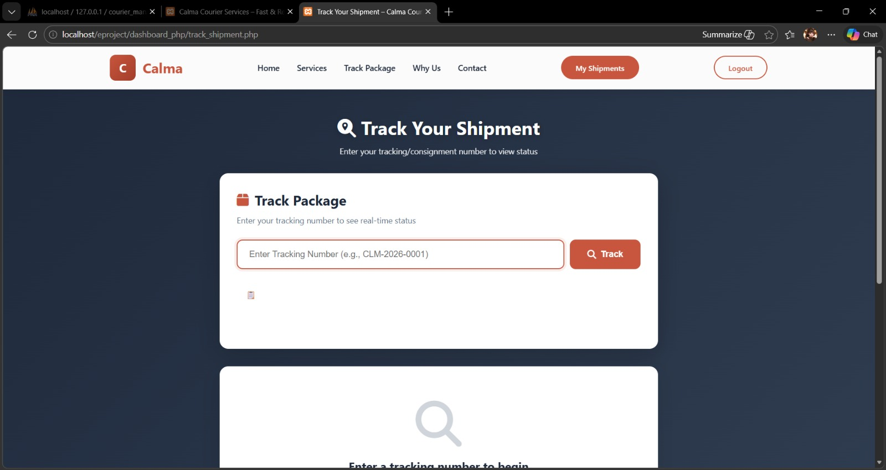

Why Us:

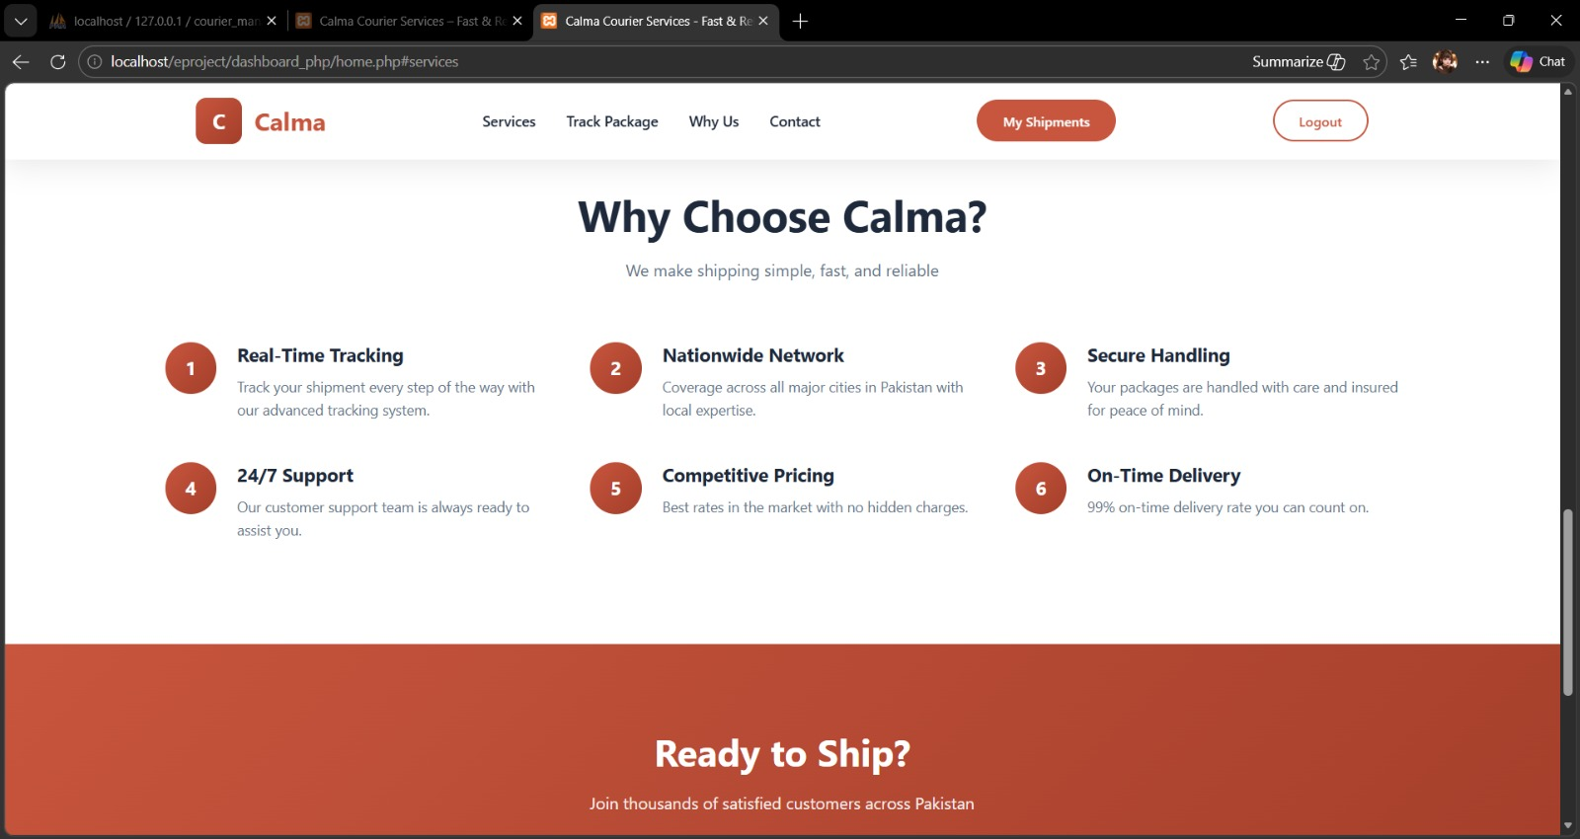

Contact:



User Dashboard:
Dashboard:

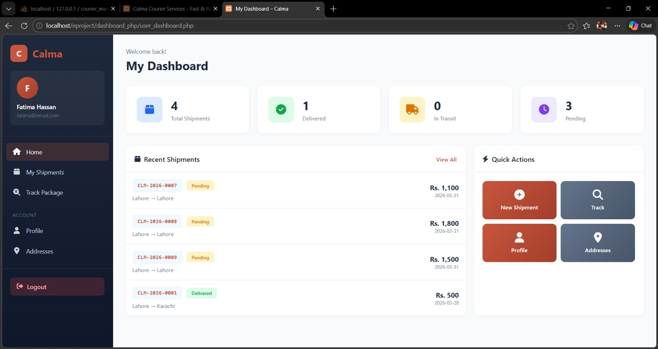

Shipments:

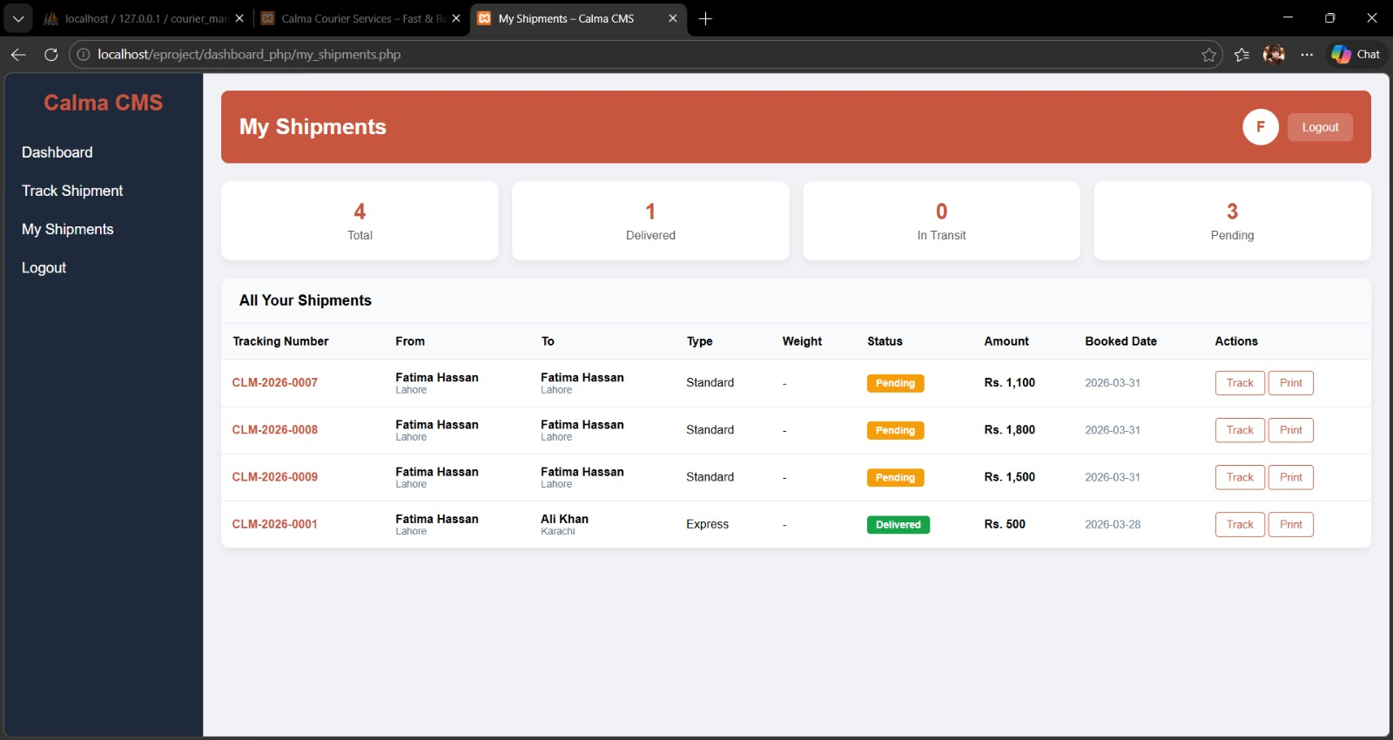

Profile:
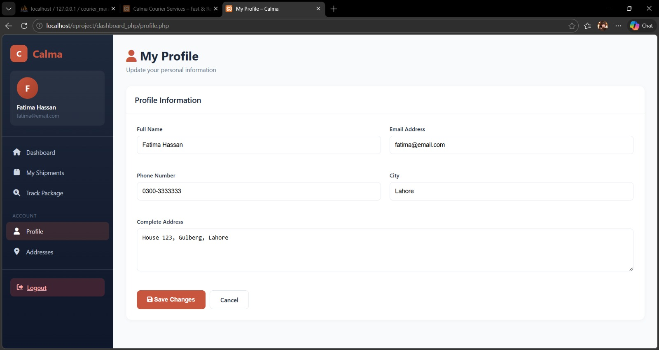

Address:
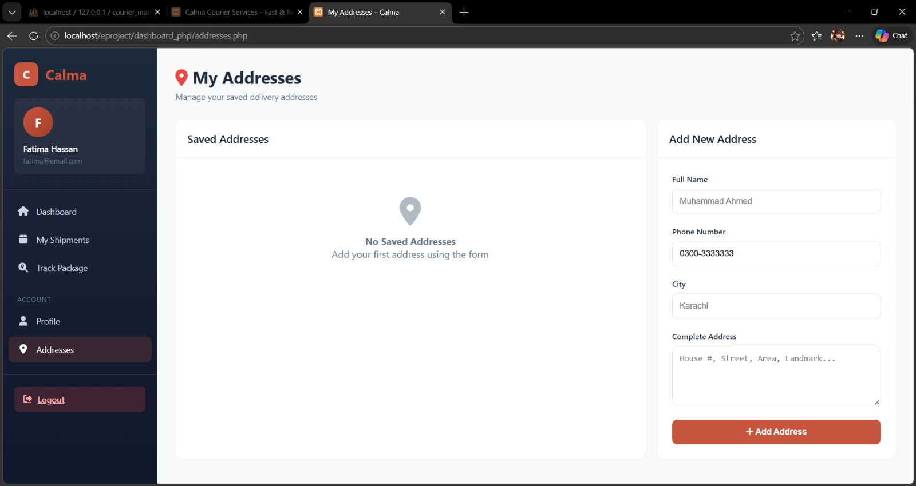

Admin Dashboard:

Dashboard:
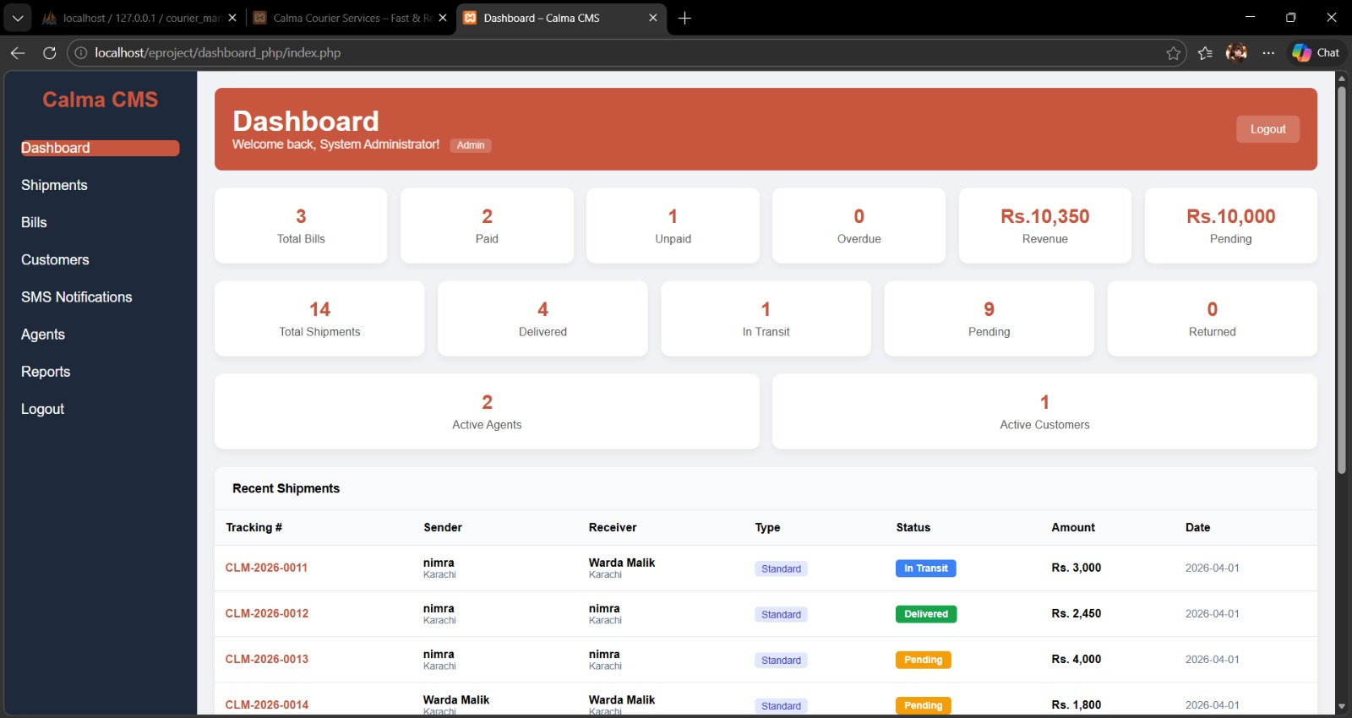

Shipments:

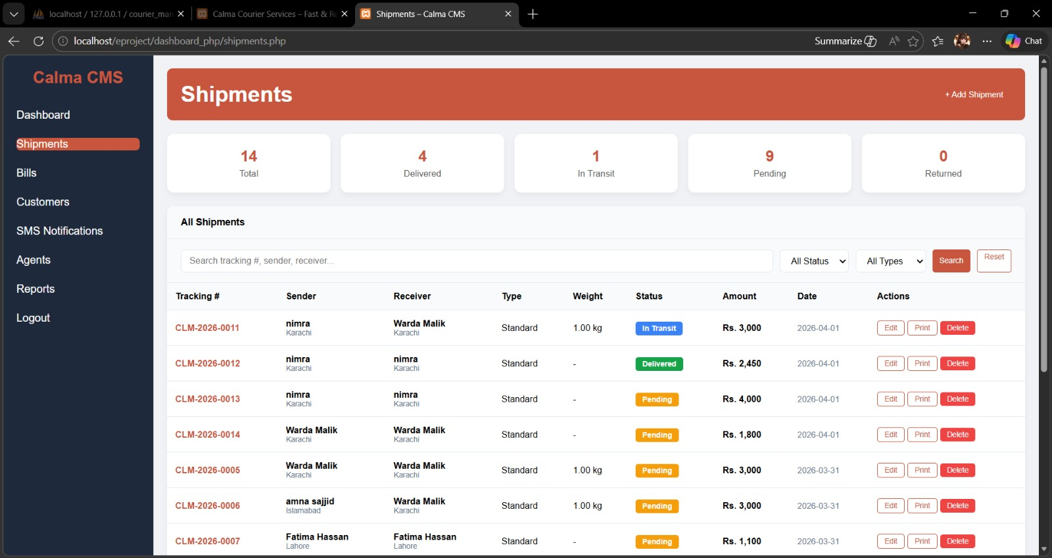

Bills:

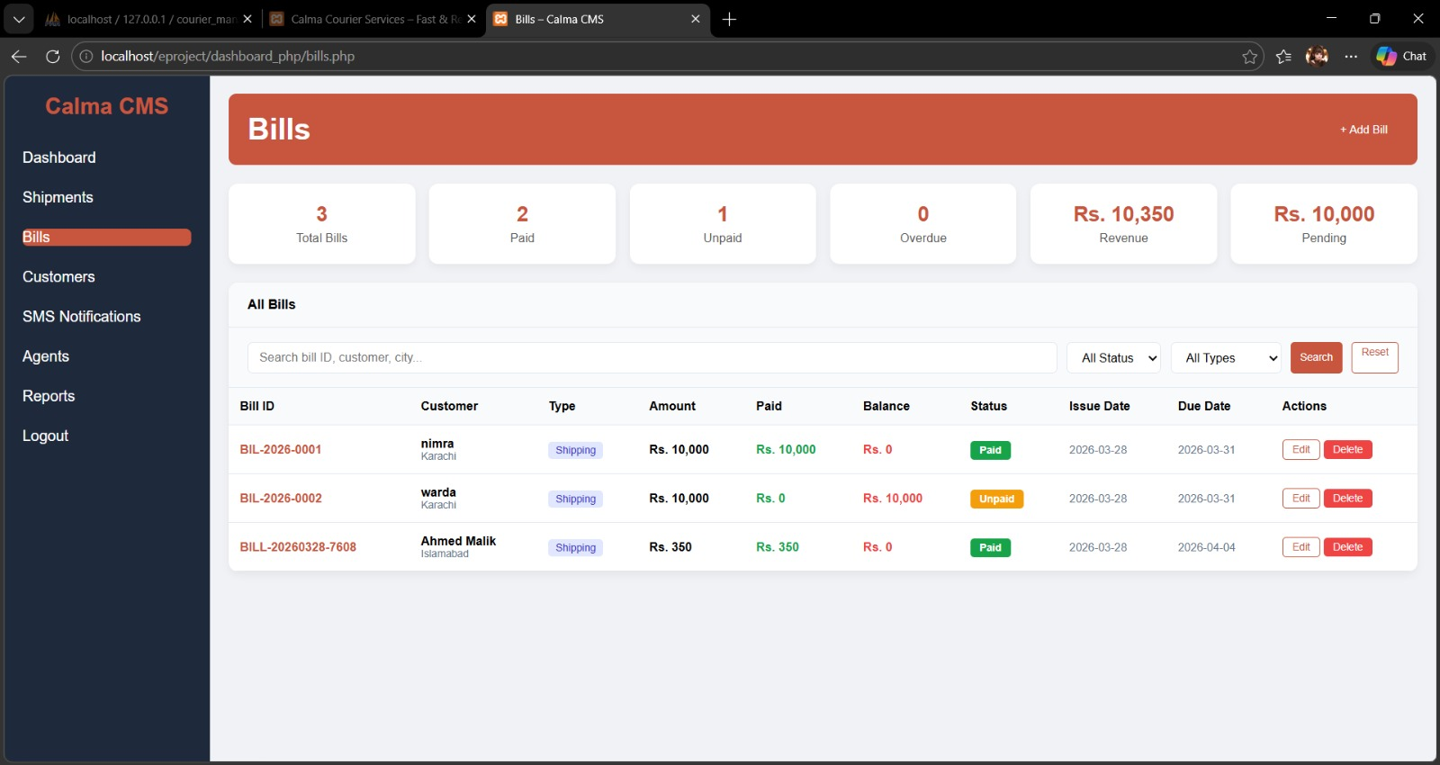

Customers:

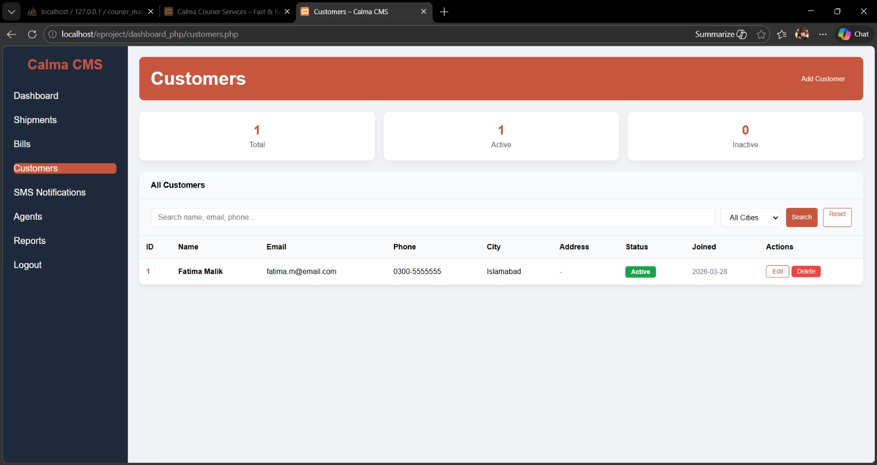

SMS Notifications:
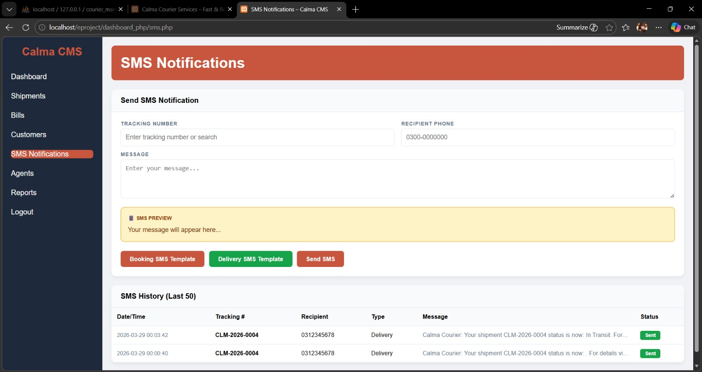

Agents:

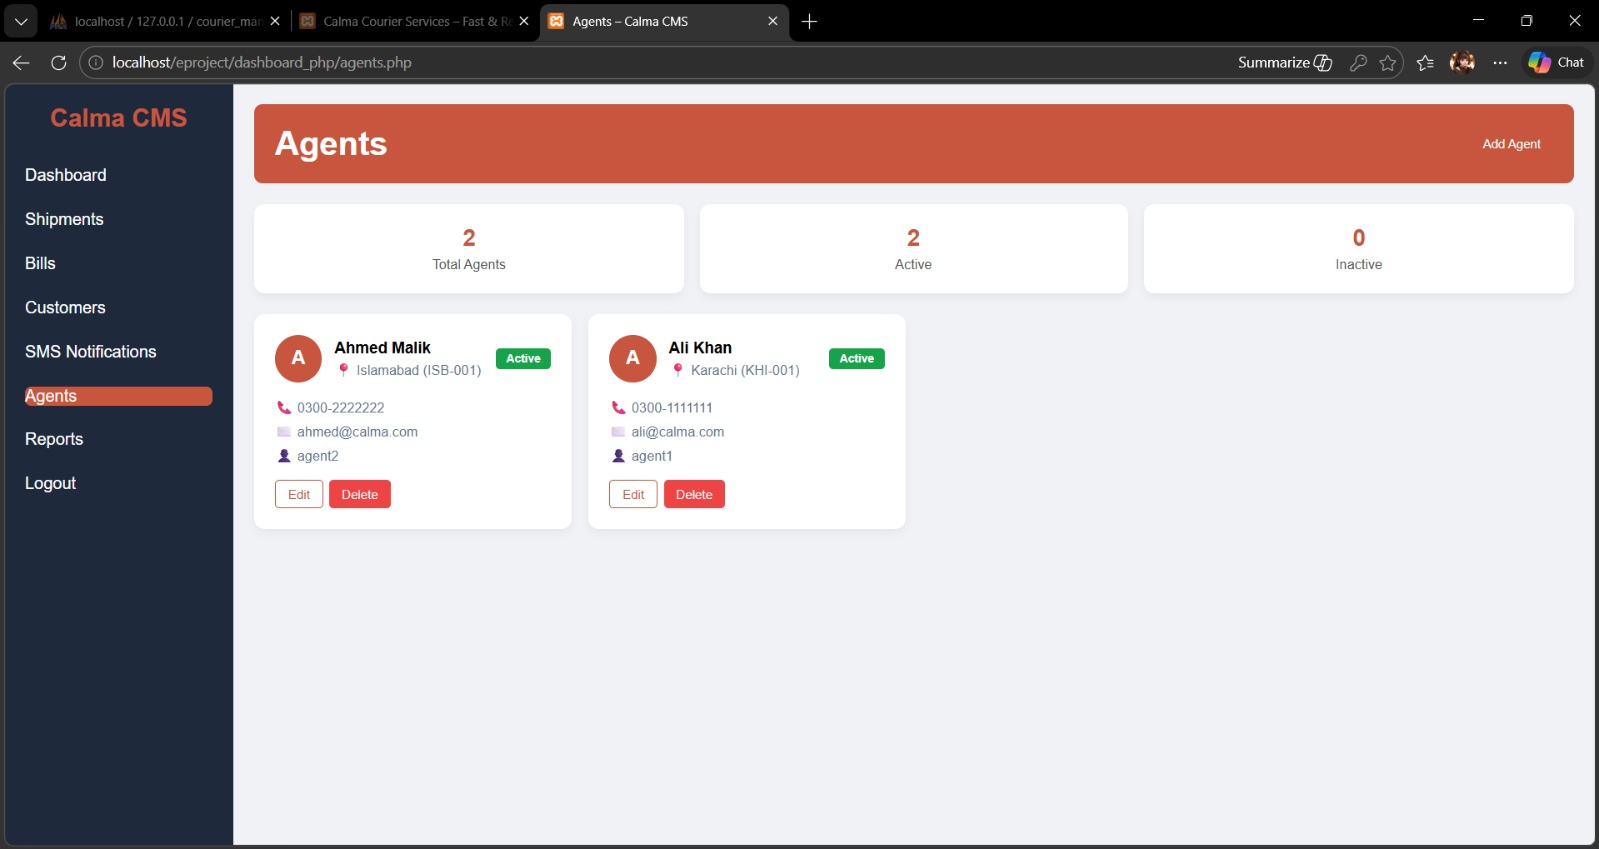

Reports:

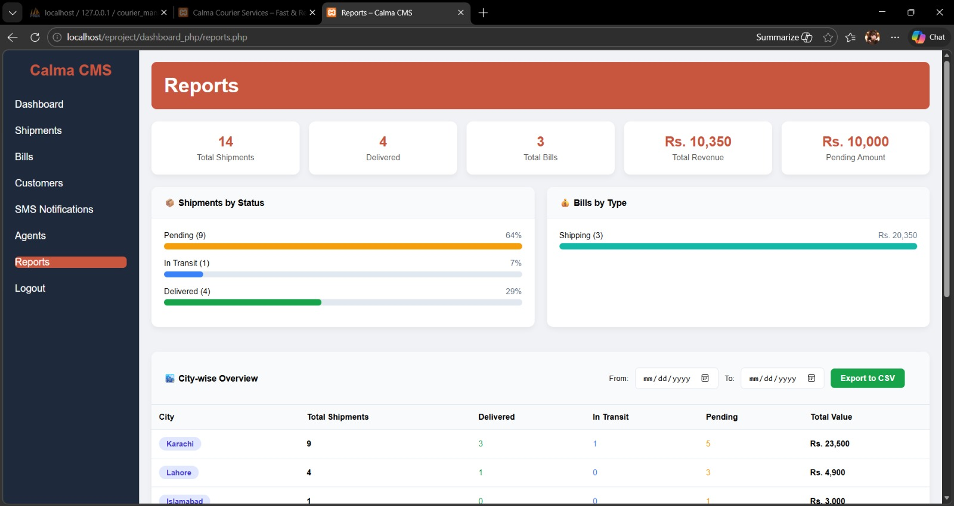

Agent Dashboard:

Agent of Karachi:

Dashboard:
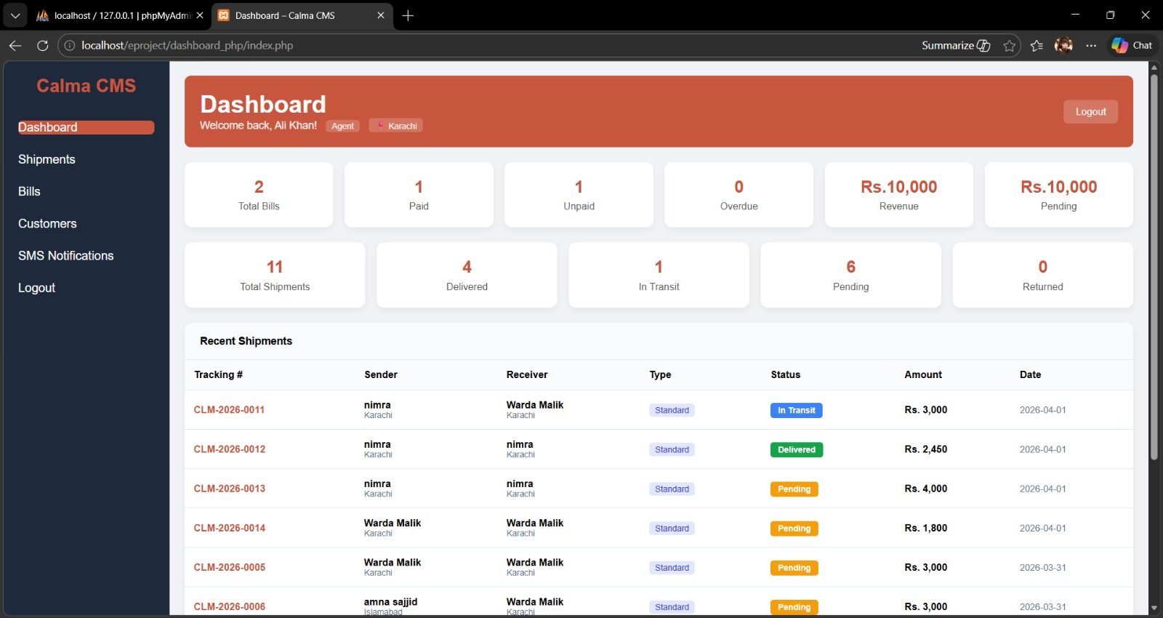

Shipments:
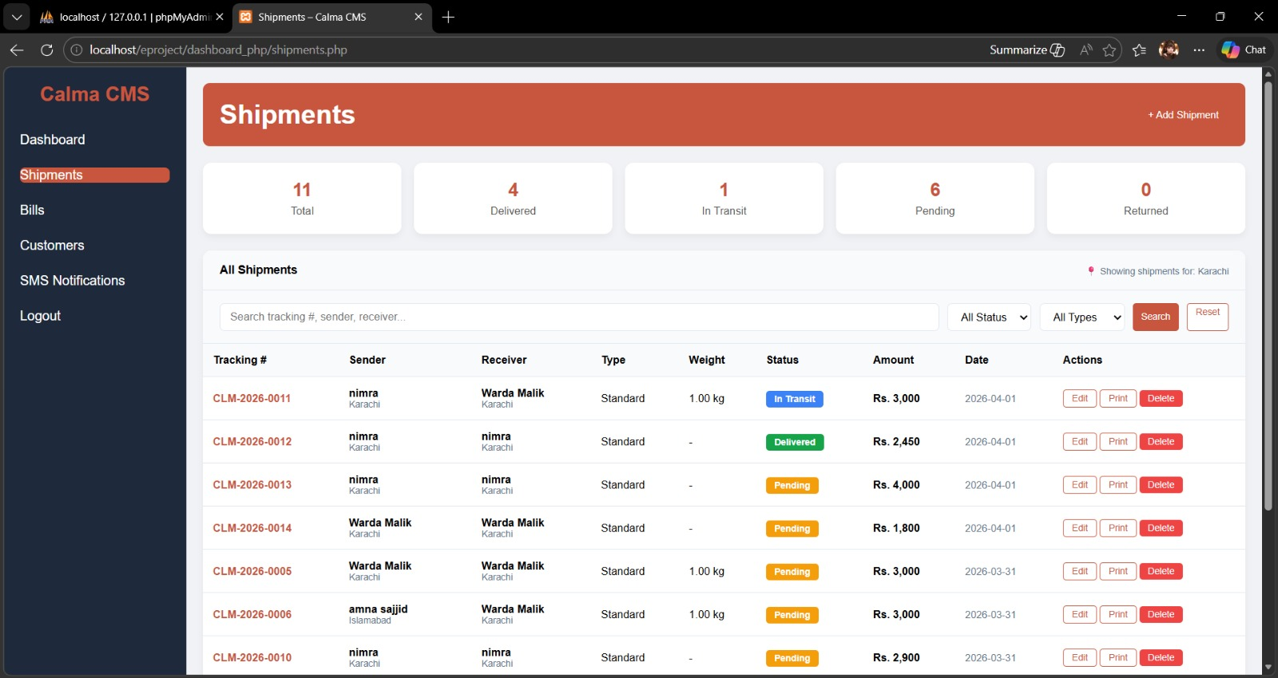

Bills:
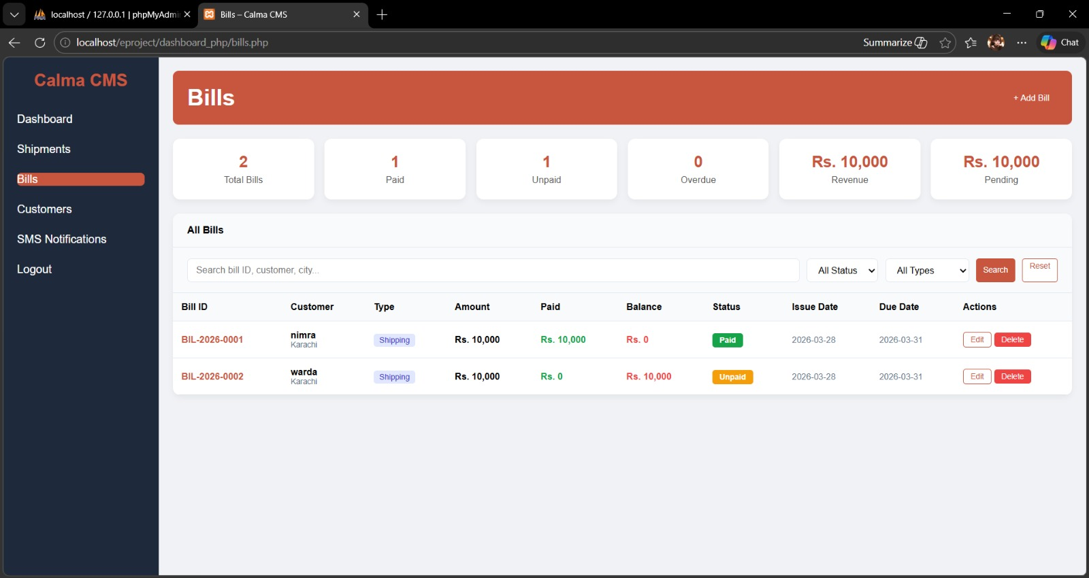

Customers:
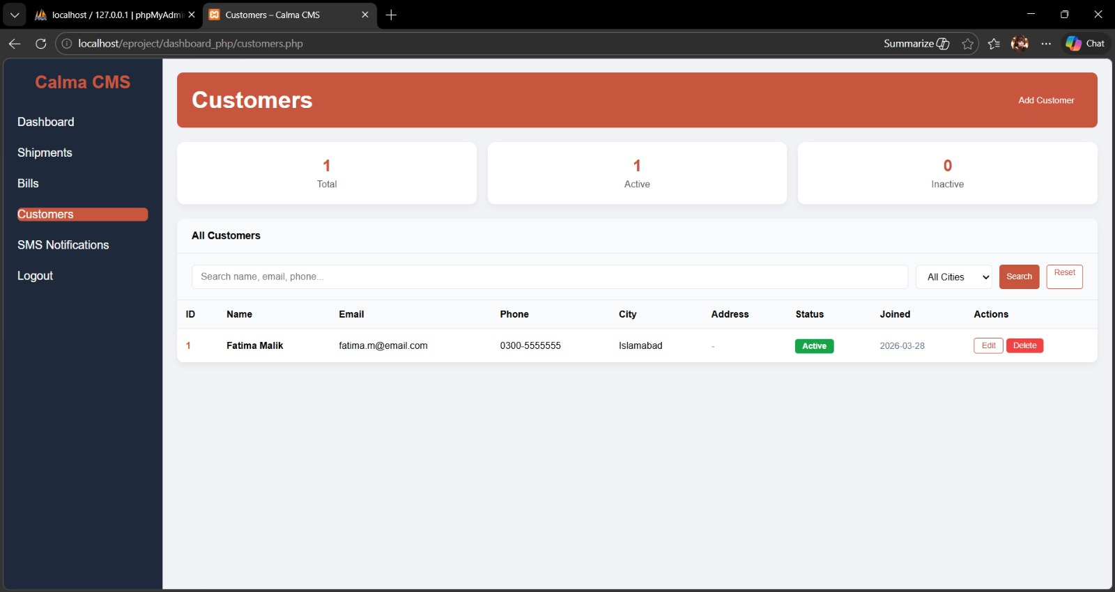

SMS Notifications:
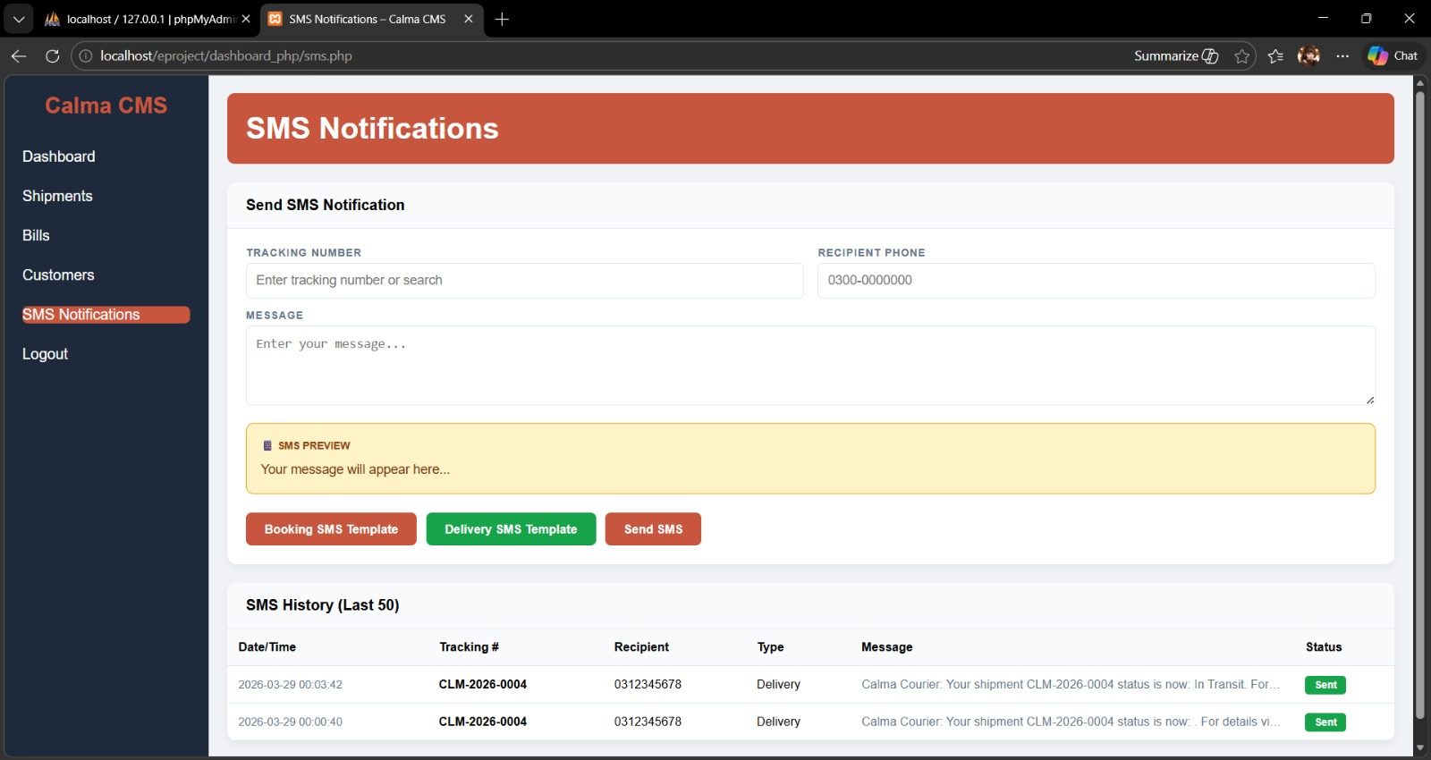

Agent of Islamabad:

Dashboard:
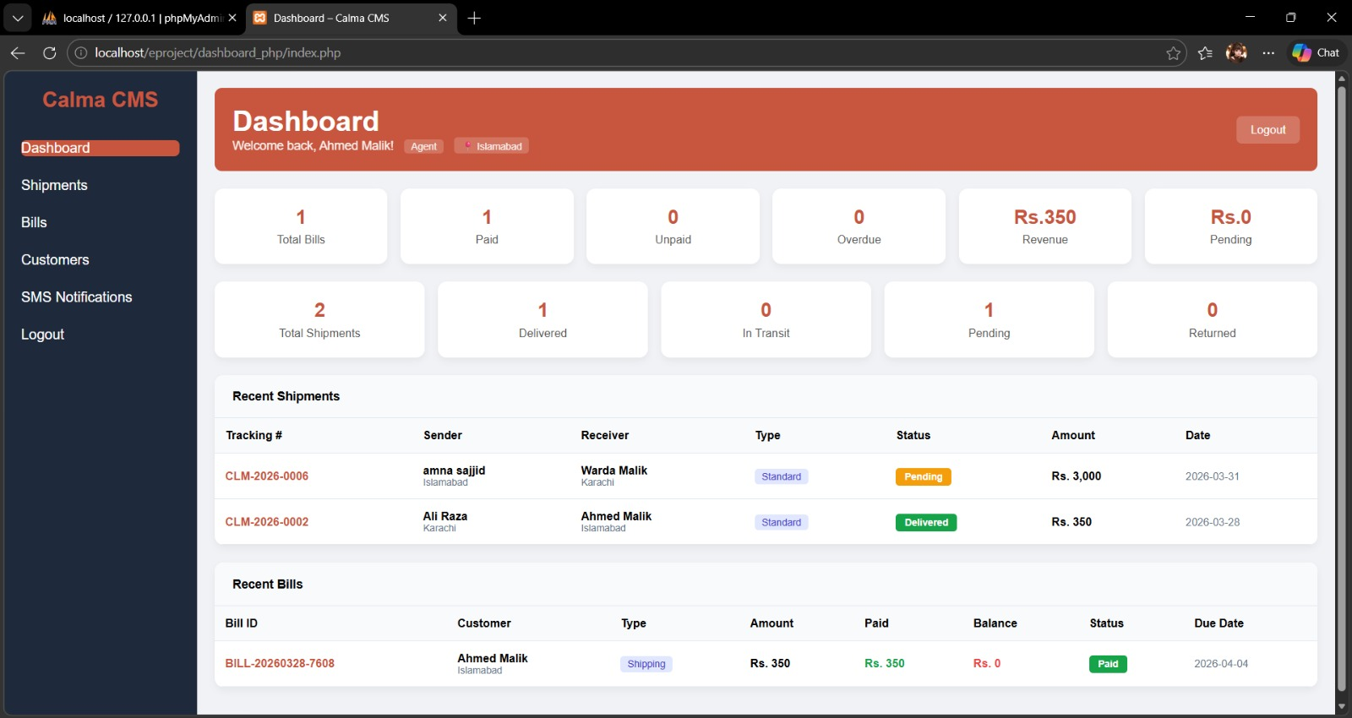

Shipments:
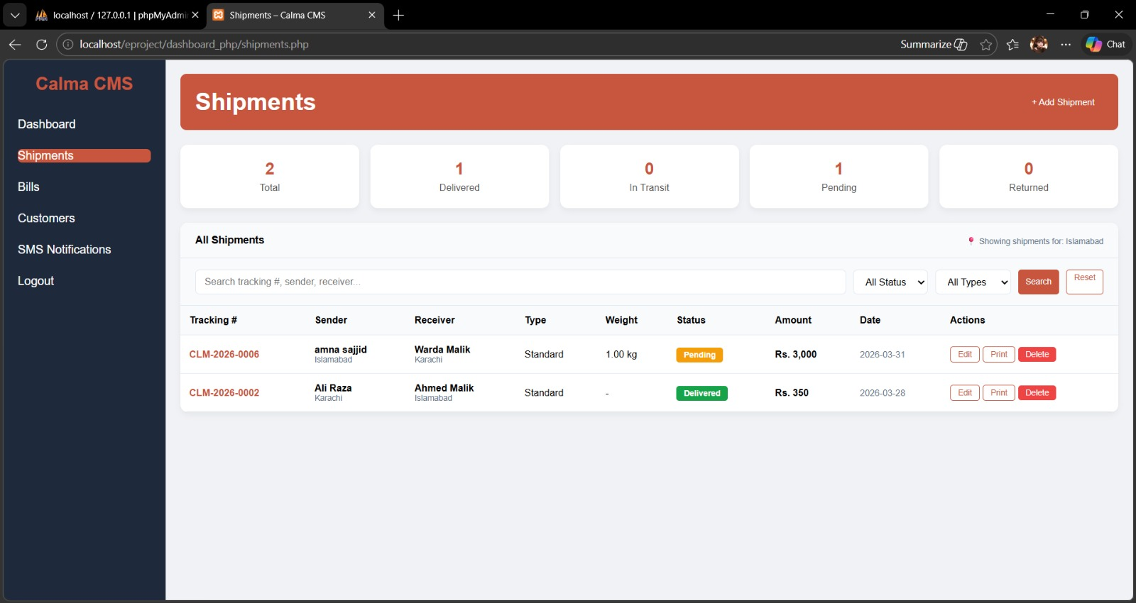
Bills:
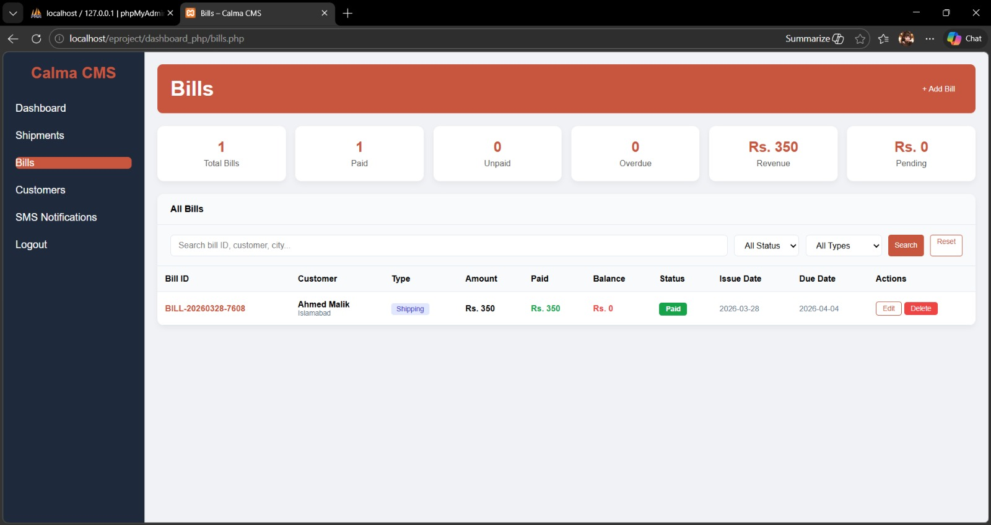

Customers:


SMS Notifications:


WIRE FRAME

Home Page:
Text
Button
Button
Button
Text
Logo
Navbar

Services:

Text

Icon
Text
Icon
Icon
Text
Text

Icon
Icon
Text
Text
Icon
Text

Track Package:

Text
Button
Search bar

Text

Why Choose Calma:

Text

Text
Text
Text
Text
Text
Text

Contact:

Text
Text

Button

Footer:

Text
Text
Text
Text

Serial NO | Names | Project Title | Task
 | Warda Malik | Courier Management System | Login/signup and search user agent and admin panel
 | Amna Sajid | Courier Management System | Website frontend and track page
 | Nimra Ghori | Courier Management System | Dashboard frontend and shipment
 | Muhammad Saad | Courier Management System | Cards

Text Sheet Review

